New Modern Duplex
“Lot 33 Tamarind Court, Woombye QLD 4559”
3 Bedroom, 2 Bathroom and Double Garage
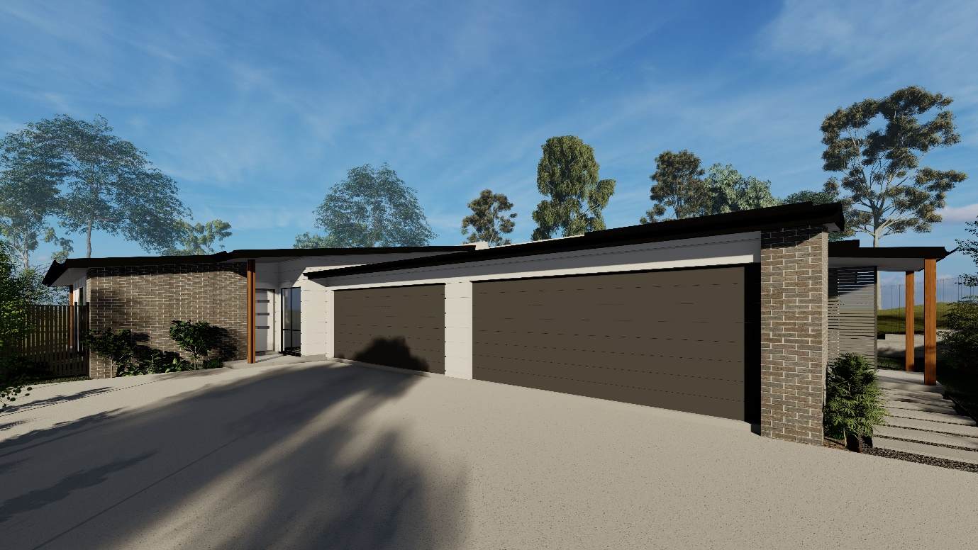

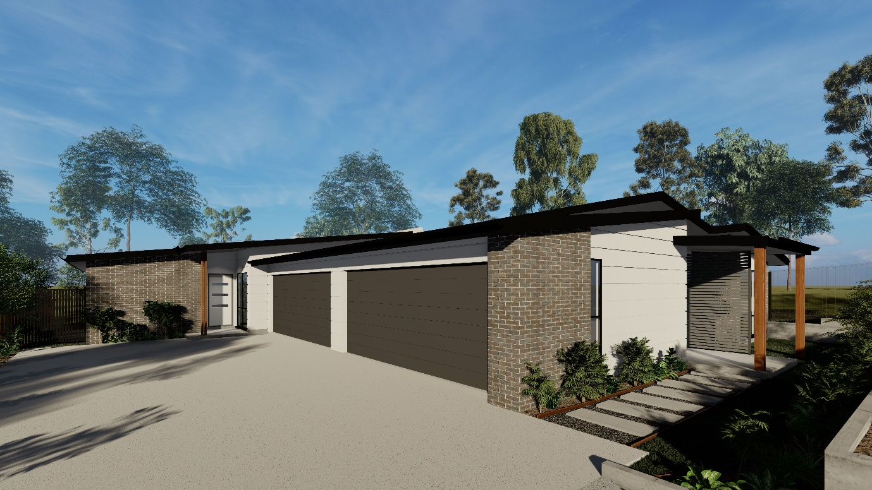

The following table outlines the finishes that have been selected.

External
- Remote control lock up garage.
- Private courtyard.
- Turf and landscaping as per plan
- Facebrick render and cladding as per plan.
- Colorbond fascia, gutter and roofing.
- Powder coated aluminium windows and fly screens to suit (excluding garage)
- Termite resistant frames where applicable.
- Termite barrier to slab penetration and external visual barrier.
- Insulation to statutory requirements as per plan.
Internal
- Bedroom flooring - carpet as per developer’s selection.
- Main flooring - tiles as per developer’s selection.
- Built in/walk in wardrobe as per plan.
- Split System Air Conditioner
- Ceiling fans throughout.
- Light fittings as per developer’s selection
- Roller blinds to all windows and sliding doors as per the developers specification/selection (excluding garage)
- Smoke detectors as per BCA requirements.
- Developer selected paint finish to all walls.
- Stainless steel single bowl laundry tub.
- Telephone point.

Kitchen
- Contemporary designed kitchen.
- Caesar stone tops.
- Tiled kitchen splashback.
- Stainless Steel sink with flick mixer tap.
- Euro Stainless steel fan forced oven.
- Euro Stainless steel gas cooktop.
- Euro Stainless steel range hood.
- Euro Stainless steel dishwasher.
Bathroom
- Tiles as per developer’s selection.
- Chrome towel rail and toilet roll holder.
- Semi Frameless shower screen.
- Ceramic toilet suite with soft close lid.
- Polyurethane vanity.
- Frameless mirror.
- White bath tub in main bathroom.
General
- Letter Box.
- TV Antenna.
- Gas Hot Water System.
- Wall mounted clothesline.

Note
Should any of the outlined finishes not be available at the time of construction, the developer will select a product of similar quality.

Artist Impressions
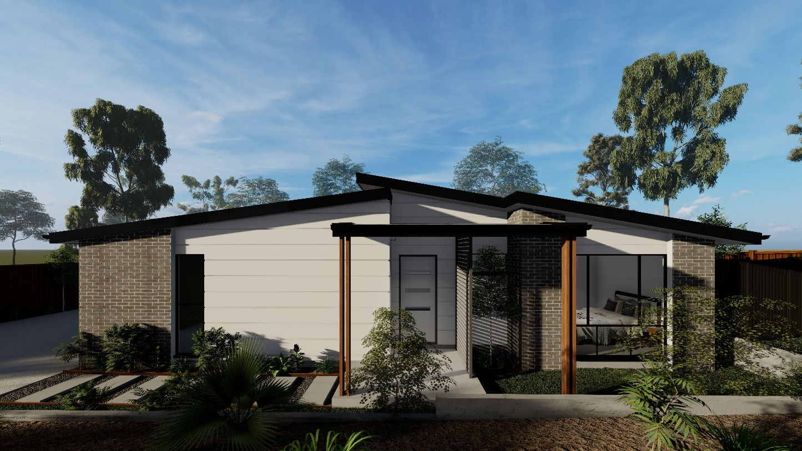

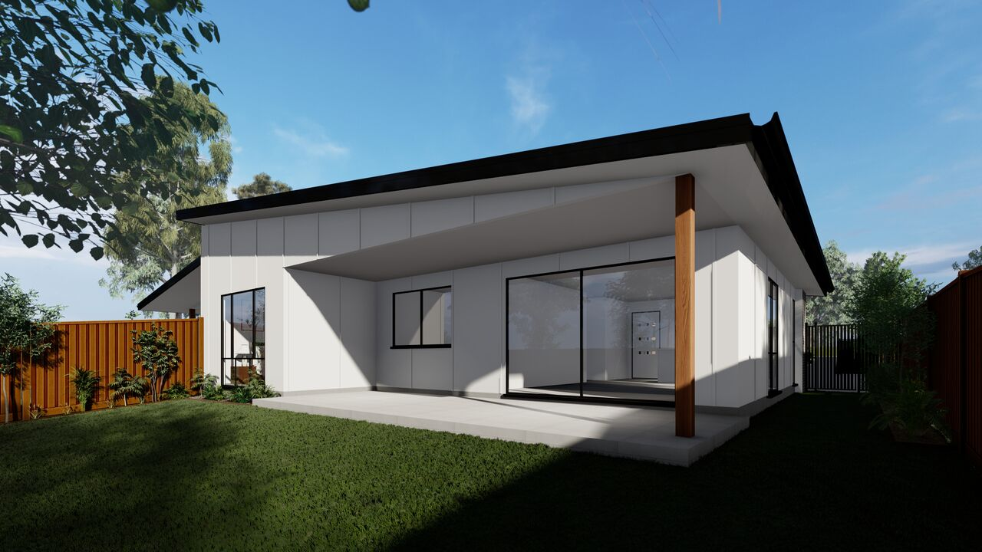

Artist Impressions
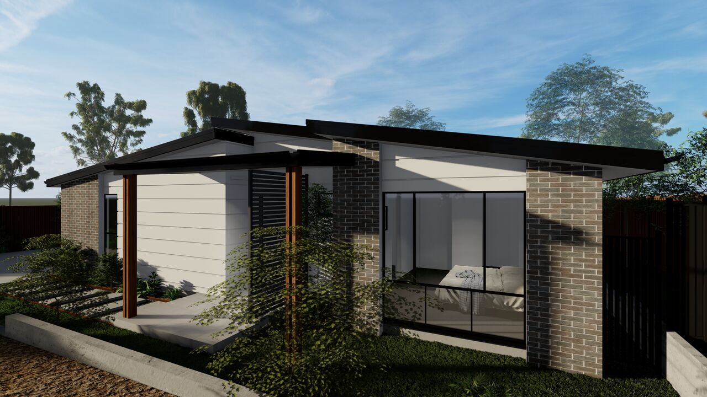

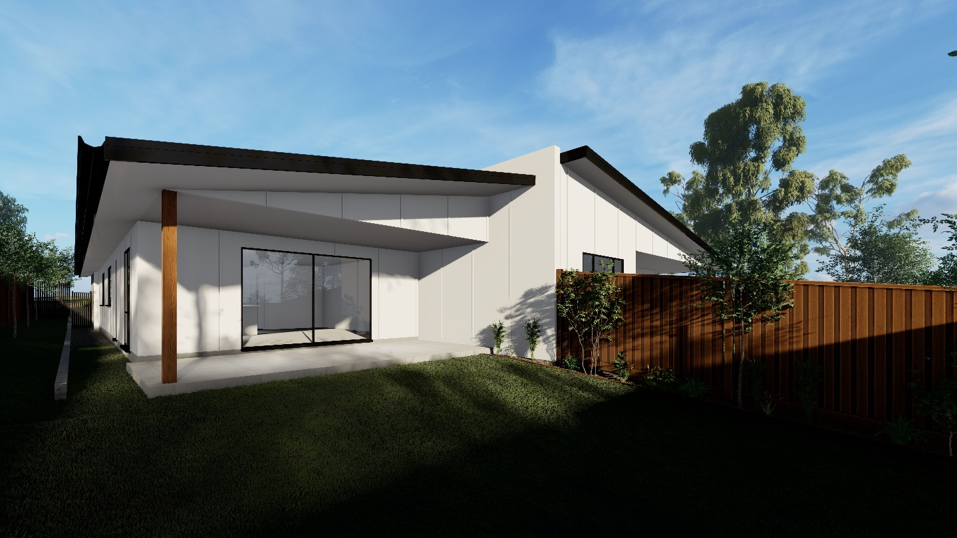

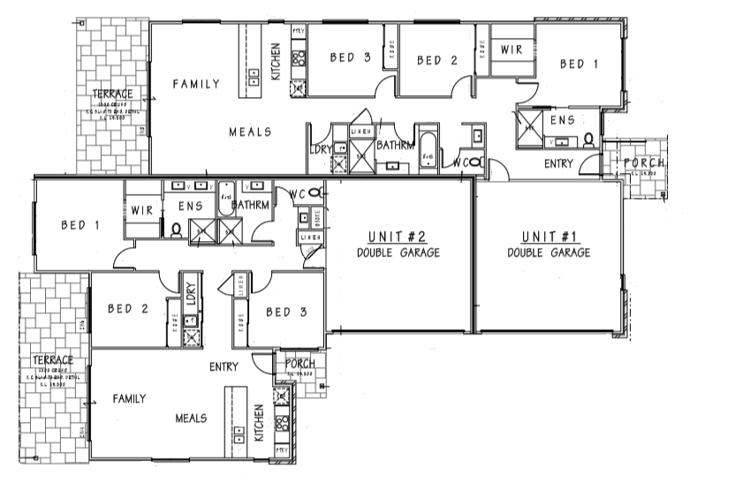
Floor Plan

